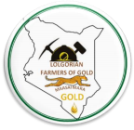LOLGORIAN
FARMERS OF GOLD SELF-HELP GROUP
Ore\Tailings - Sample
Date____________
Sample ID #_________
Collection Agent___________________________

Reference # | Date | Ore\Tailings | Location | Gps | Quantity | Depth | Notes
CU-MH-Lolg-001 | 8-31-21 | T | Lolgorian |  | 2kg | 80ft

Recommended Testing Lab in Migori
Jeymatian Mineral Laboratory (JML)
Email: jeymatian@gmail.com
Phone: +254-720-731-171

